Thinking about a place to start. According to the original equations, I have devised a matrix-differential form. Let’s begin here. The original equation is listed:
Pertains to:

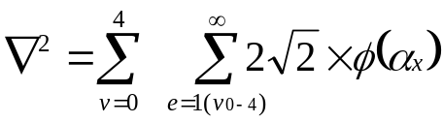
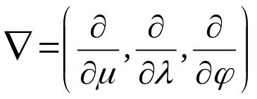

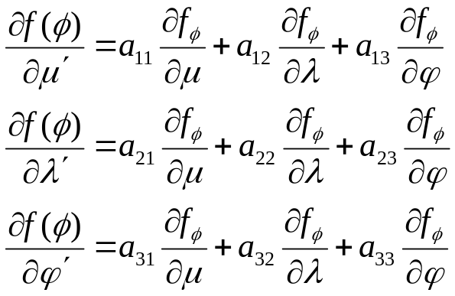As:

Which what follows is expanded into the forms:
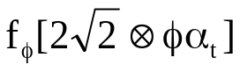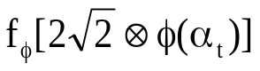

z:
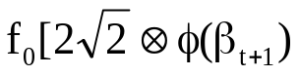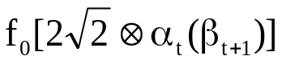

Z:
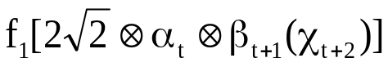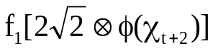

X:
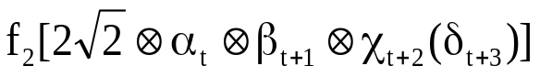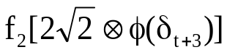

V:
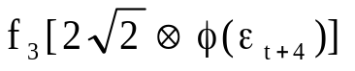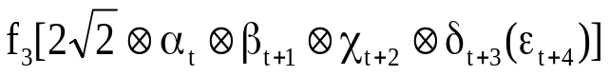

L:

Of the driving function:
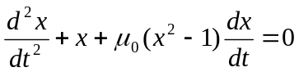
Where:
in an iteration sequence determined by (1.9).
But for the purposes of ease of checking the theory a simple derivative will be used:
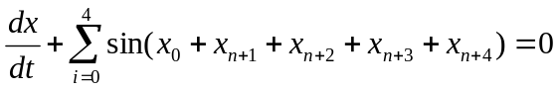
Where the values are assigned their hardware values of:
But equation 1.1 needs to be arranged as:
(1.9)
Where f(φ_{x}) = the driving function.
Now onto block assignments:
A picture of what I’m thinking:

1. Input the data
2. Access the data
3. Contemplate the data
4. Organize the data
5. Output the data
From external sensory/motor system
To external sensory/motor system
Short-term memory
Long-term memory
Sydrandria Codes
c
6bh
3fj
l
Base-5 Computation

And:
Single block 0 – 4:
NULL | 0 | 1 | 2 | 3 | 4
0 | z | Z | X | V | L

